Kunal, मी तुझ्या Sir च्या notes आणि diagrams व्यवस्थित पाहिले. खाली मी त्यांना Professional Docker Notes format मध्ये arrange केले आहे.
- Important concepts retain केले आहेत.
- Grammar आणि technical mistakes correct केल्या आहेत.
- Diagrams मधील concepts सुद्धा include केले आहेत.
- Unnecessary information add केलेली नाही.
- Interview आणि revision साठी useful format ठेवला आहे.
DOCKER NOTES
Day 1
Fundamentals & Architecture
1. Monolithic vs Microservices Architecture
Monolithic Architecture
A monolithic application is built as a single codebase where multiple modules are integrated into one application.
Example: E-Commerce Application
- Product Catalog
- Shopping Cart
- Orders
Characteristics
- Single codebase
- All modules are tightly coupled.
- Any change may require rebuilding and redeploying the entire application.
- Failure in one module may affect the entire application.
- Scaling individual modules is difficult.
Microservices Architecture
Microservices is an architectural approach where an application is divided into small, independent services. Each service handles a specific business functionality.
Example: Banking Application
- Internet Banking
- Mobile Banking
- Loans
- Insurance
- Payments
Characteristics
- Each service can be developed independently.
- Services communicate through APIs.
- Individual services can be deployed independently.
- Each service can be scaled separately.
- Failure in one service does not necessarily affect the entire application.
Difference Between Monolithic and Microservices
Monolithic | Microservices
Single codebase | Multiple independent services
Tightly coupled | Loosely coupled
Entire application deployment | Individual service deployment
Difficult to scale individual modules | Easy to scale individual services
Technology is generally shared | Different technologies can be used
2. Physical Machine vs Virtual Machine vs Container
Physical Machine
A physical machine is a computer with dedicated hardware resources such as CPU, RAM, storage, and network interfaces.
Virtual Machine (VM)
A Virtual Machine is a software-based computer that runs on physical hardware through a Hypervisor.
Each VM has its own Guest Operating System.
Container
A container is a lightweight, isolated environment used to run an application along with its dependencies.
Containers share the host operating system's kernel instead of running a separate guest OS for each container.
Comparison
Physical Machine | Virtual Machine | Container
Dedicated hardware | Virtualized hardware | OS-level virtualization
Runs directly on hardware | Runs through hypervisor | Runs through container runtime
Full OS | Separate guest OS | Shares host kernel
High resource usage per workload | More resource usage | Lightweight
Slower startup | Slower startup | Fast startup
Less workload density | Moderate workload density | High workload density
Advantages of Containers
- Lightweight
- Fast startup
- Less resource consumption
- Application isolation
- Easy portability
- Easy scaling
- Efficient resource utilization
3. What is Containerization?
Containerization is the process of packaging an application along with its libraries, dependencies, and configurations into a single deployable unit called a container image.
The application runs inside an isolated environment called a container.
Problem Before Containerization
In traditional development, applications depend on several components.
Example:
- Jenkins requires Java.
- AWS CLI requires Python runtime support.
- Tomcat requires Java.
- Applications require specific libraries and dependencies.
Problems occur when development and testing environments have different configurations or software versions.
Example:
Developer Environment:
- Java
- Tomcat
- Application
- Required Libraries
Testing Environment:
- Java version mismatch
- Missing libraries
- Different configurations
Result: Application may work in development but fail in testing.
Solution: Docker
Docker packages the application and its required dependencies into an image.
This helps maintain consistency across development, testing, and production environments.
4. What is Docker?
Docker is an open-source containerization platform used to build, package, run, and deploy applications inside containers.
Key Points
- Introduced in 2013.
- Written in Go programming language.
- Uses OS-level virtualization.
- Uses host resources such as CPU, RAM, and storage.
- Supports application portability.
- Commonly used in Linux environments and also available on Windows and macOS.
- Docker Compose uses YAML files to define and manage multi-container applications.
Docker Alternatives
- Podman
- containerd
- CRI-O
- rkt (historical)
5. Docker Components
Docker consists of four major components.
1. Docker Client
The Docker Client is the interface through which users interact with Docker.
It accepts commands and sends requests to the Docker Daemon through the Docker REST API.
Example:
docker run nginx
docker ps
docker images
docker stop container_id
2. Docker Host
The Docker Host is the machine where Docker Engine is installed.
Examples:
- AWS EC2
- Linux Server
- Virtual Machine
- Laptop
3. Docker Daemon
The Docker Daemon (dockerd) is a background service responsible for managing Docker objects.
Responsibilities:
- Pulling images
- Building images
- Creating containers
- Starting and stopping containers
- Managing networks
- Managing volumes
4. Docker Registry
A Docker Registry is a service used to store, manage, and distribute Docker images.
Example: Docker Hub
Other examples include Amazon ECR and private Docker registries.
6. Docker Architecture
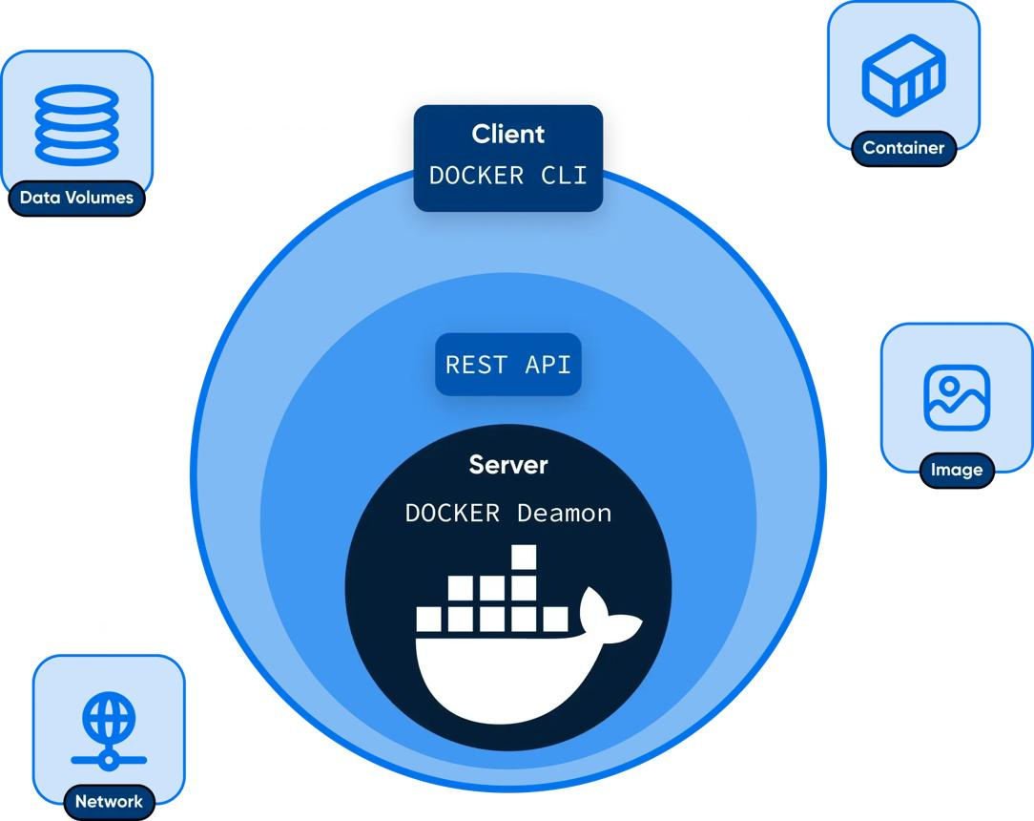
dreamhost.com
Docker follows a Client-Server Architecture.
Architecture Flow
Docker Client
|
|
Docker REST API
|
▼
Docker Daemon
dockerd
|
---------------------
| | |
▼ ▼ ▼
Images Containers Networks
|
Volumes
|
▼
Container Runtime
(containerd/runc)
|
▼
Linux Kernel
-------------------
Namespaces
Cgroups
OverlayFS
Working
- User executes a Docker command using Docker CLI.
- Docker Client sends the request through REST API.
- Docker Daemon receives and processes the request.
- Daemon checks whether the required image is available locally.
- If the image is unavailable, Docker pulls it from a registry.
- Docker creates and starts the container.
- The container uses host kernel resources.
7. Docker Objects
Docker Daemon manages the following objects:
Object | Description
Image | Read-only template used to create containers
Container | Running or stopped instance of an image
Network | Enables communication between containers
Volume | Provides persistent data storage
8. Docker Image vs Docker Container
Docker Image
A Docker Image is a read-only template containing the application, dependencies, libraries, and filesystem layers required to create a container.
Images are built using a Dockerfile.
Docker Container
A Docker Container is an isolated runtime instance created from a Docker Image.
Example
Docker Image
|
-----------------
| | |
▼ ▼ ▼
Container Container Container
1 2 3
One Docker Image can be used to create multiple containers.
9. Dockerfile, Image and Container Workflow
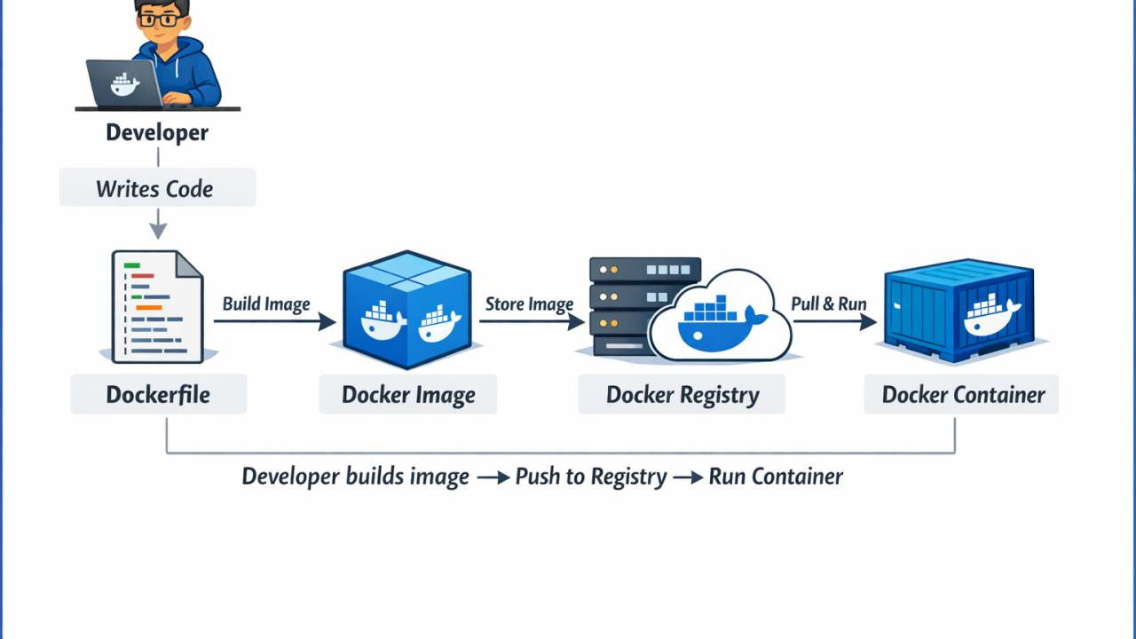
linkedin.com
Step 1: Dockerfile
A Dockerfile contains instructions to build a Docker Image.
Step 2: Build Image
docker build -t myapp:v1 .
Step 3: Run Container
docker run -d --name app1 myapp:v1
Step 4: Create Multiple Containers
docker run -d --name app2 myapp:v1

docker run -d --name app3 myapp:v1
Step 5: Push Image to Docker Hub
docker login

docker tag myapp:v1 username/myapp:v1

docker push username/myapp:v1
Step 6: Pull Image
docker pull username/myapp:v1
10. Docker Registry
A Docker Registry stores and distributes Docker Images.
Docker Hub
Docker Hub is a popular public Docker Registry where users can:
- Upload images
- Download images
- Share images
- Maintain image repositories
Important Commands
Command | Purpose
docker login | Login to registry
docker pull | Download image
docker push | Upload image
docker images | List local images
docker search | Search Docker Hub
11. Docker vs Virtual Machines
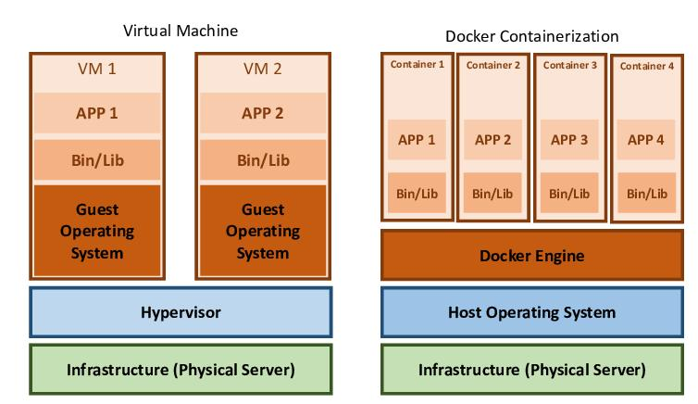
researchgate.net
Virtual Machine Architecture
Physical Hardware
|
Hypervisor
----------------
| | |
▼ ▼ ▼
VM1 VM2 VM3
| | |
OS OS OS
| | |
App App App
Docker Architecture
Physical Hardware
|
Host Operating System
|
Docker Engine
-------------------
| | |
▼ ▼ ▼
Container Container Container
| | |
App App App
Comparison
Virtual Machines | Docker Containers
Uses Hypervisor | Uses Container Engine
Each VM has its own OS | Shares host kernel
Higher resource consumption | Lower resource consumption
Longer boot time | Faster startup
Larger disk footprint | Smaller footprint
VM images are comparatively large | Container images are generally smaller
Scaling requires more resources | Lightweight scaling
12. How Docker Works Internally
Docker uses Linux Kernel features to provide isolation and resource management.
1. Namespaces
Namespaces provide isolation between containers.
Namespace | Purpose
PID | Process isolation
NET | Network isolation
MNT | Mount and filesystem isolation
UTS | Hostname isolation
IPC | Inter-process communication isolation
USER | User and group isolation
2. Cgroups (Control Groups)
Cgroups control and limit the resources consumed by containers.
Examples:
- CPU
- Memory
- I/O
This prevents a container from consuming unlimited system resources when appropriate limits are configured.
3. OverlayFS
OverlayFS is a union filesystem commonly used by Docker to manage image layers and container writable layers efficiently.
Why Containers Are Lightweight?
Containers share the host kernel instead of running a separate guest OS for every container.
13. Docker Lifecycle
Docker Image
|
▼
docker run
|
▼
Container Created
|
▼
Container Running
/ \
▼ ▼
Paused Stopped
| |
▼ ▼
Unpause Restart
|
▼
Running
|
▼
Remove
|
▼
Deleted
Important Commands
docker run
docker pause
docker unpause
docker stop
docker start
docker restart
docker rm
14. Docker Editions
Historically, Docker was distributed in two main editions.
Community Edition (CE) | Enterprise Edition (EE)
Community-focused | Enterprise-focused
Free and open source | Commercial offering
Developers and learners | Enterprise organizations
Core Docker functionality | Enterprise support and additional capabilities
Note: Docker's product and licensing structure has evolved. Docker Engine and Docker Desktop have different licensing terms.
15. OCI (Open Container Initiative)
What is OCI?
The Open Container Initiative (OCI) is an open standard that defines specifications for container images and runtimes to ensure portability across different platforms.
- Launched in 2015.
- Hosted under the Linux Foundation.
- Supported by companies including Docker, Red Hat, and Google.
Why OCI Was Needed?
Before OCI:
- Different vendors could use different image formats.
- Images might not work across different container platforms.
- There was no common standard.
OCI introduced standard specifications to improve interoperability.
OCI Specifications
1. OCI Image Specification
Defines:
- Image format
- Image layers
- Image manifest
- Image configuration
2. OCI Runtime Specification
Defines:
- How containers are created and run
- Process execution
- Filesystem configuration
- Namespaces and cgroups configuration
OCI-Compatible Technologies
- Docker
- containerd
- CRI-O
- Podman
Important Revision Points
- Docker is a containerization platform.
- Containerization is OS-level virtualization.
- Docker follows Client-Server Architecture.
- Docker CLI communicates with Docker Daemon through REST API.
- Docker Daemon manages images, containers, networks, and volumes.
- Dockerfile is used to build an image.
- Docker Image is used to create containers.
- Containers share the host OS kernel.
- Namespaces provide isolation.
- Cgroups manage resource limits.
- Docker Hub is a container image registry.
- OCI provides standard specifications for container images and runtimes.
हे तुझे Docker Day 1 चे complete, cleaned notes आहेत. पुढचे Docker topics शिकताना याच format मध्ये notes ठेवूया, म्हणजे तुझ्याकडे शेवटी एक proper Docker revision notebook तयार होईल.

